สมุดบันทึก
การปฏิบัติกิจกรรมชุมนุม

ภาคเรียนที่ 2
ปีการศึกษา 2563

กิจกรรมชุมนุม............................................

ครูที่ปรึกษาชุมนุม........................................

งานกิจกรรมพัฒนาผู้เรียน
กลุ่มบริหารวิชาการ

แบบบันทึกผลการประเมินกิจกรรมพัฒนาผู้เรียน
โรงเรียนศรีอยุธยา ในพระอุปถัมภ์ฯ
******************************************************

กิจกรรมชุมนุม..........................................................................................................
ภาคเรียนที่ 2 ปีการศึกษา 2563
สถานที่ปฏิบัติกิจกรรมชุมนุม..........................................................
ครูที่ปรึกษากิจกรรมชุมนุม.......................................................................................

สรุปผลการประเมินกิจกรรมชุมนุม
จำนวนนักเรียนทั้งหมด (คน) | ผลการประเมิน |  | หมายเหตุ
 | ผ่าน(คน) | ไม่ผ่าน(คน)
ระบุชื่อนักเรียนที่ไม่ผ่าน
1....................................
2....................................
3....................................

ลงชื่อ................................................
(............................................................................)
ครูที่ปรึกษากิจกรรมชุมนุม

ลงชื่อ................................................
(นางสาวสุวรรณา ทัพทวี)
หัวหน้ากิจกรรมชุมนุม
โรงเรียนศรีอยุธยา ในพระอุปถัมภ์ฯ
******************************************************

1. ชื่อกิจกรรมชุมนุม..................................................................................................................................................
2. หลักการและเหตุผล
....................................................................................................................................................................................
....................................................................................................................................................................................
....................................................................................................................................................................................
....................................................................................................................................................................................
....................................................................................................................................................................................
3. วัตถุประสงค์
1)............................................................................................................................................................................
2)............................................................................................................................................................................
3)............................................................................................................................................................................
4. เป้าหมาย
เชิงปริมาณ
1)............................................................................................................................................................................
เชิงคุณภาพ
1)............................................................................................................................................................................
5. กิจกรรมชุมนุม.........................................................................................................ส่งเสริมการวัดแววในด้านใด
แววผู้นำ
..........................................................................................................................................................................
..........................................................................................................................................................................
แววนักกีฬา
..........................................................................................................................................................................
..........................................................................................................................................................................
แววศิลปิน
..........................................................................................................................................................................
..........................................................................................................................................................................

แววนักคิด
..........................................................................................................................................................................
..........................................................................................................................................................................
แววนักวิชาการ
..........................................................................................................................................................................
..........................................................................................................................................................................
แววนักสร้างสรรค์
..........................................................................................................................................................................
..........................................................................................................................................................................
แววนักภาษา
..........................................................................................................................................................................
..........................................................................................................................................................................
แววดนตรี
..........................................................................................................................................................................
..........................................................................................................................................................................
แววนักวิทยาศาสตร์
..........................................................................................................................................................................
..........................................................................................................................................................................
แววนักคณิตศาสตร์
..........................................................................................................................................................................
..........................................................................................................................................................................
6. การบูรณาการหลักปรัชญาของเศรษฐกิจพอเพียง
....................................................................................................................................................................................
....................................................................................................................................................................................
....................................................................................................................................................................................
....................................................................................................................................................................................
7. การดำเนินการ
ขั้นเตรียมการ
1)............................................................................................................................................................................
2)............................................................................................................................................................................
3)............................................................................................................................................................................
ขั้นดำเนินการ
1)............................................................................................................................................................................
2)............................................................................................................................................................................
3)............................................................................................................................................................................
ขั้นสรุปและประเมินผล
1)............................................................................................................................................................................
2)............................................................................................................................................................................
3)............................................................................................................................................................................
8. ระยะเวลาการดำเนินงาน..........................................................................................................................................
9. สถานที่ดำเนินงาน......................................................................................................................................................
10. ประโยชน์ที่คาดว่าจะได้รับ
1)............................................................................................................................................................................
2)............................................................................................................................................................................
3)............................................................................................................................................................................

11. ผู้รับผิดชอบ (นักเรียน)
1)....................................................................................................ประธานกิจกรรมชุมนุม(นักเรียน)
2)....................................................................................................รองประธานกิจกรรมชุมนุม(นักเรียน)
3)....................................................................................................เลขานุการ(นักเรียน)
12. ความคิดเห็นของครูที่ปรึกษากิจกรรมชุมนุม
....................................................................................................................................................................................
....................................................................................................................................................................................
....................................................................................................................................................................................
....................................................................................................................................................................................
....................................................................................................................................................................................
....................................................................................................................................................................................
....................................................................................................................................................................................
....................................................................................................................................................................................

ลงชื่อ.................................................................ครูที่ปรึกษากิจกรรมชุมนุม
(........................................................................)
............../................/.................

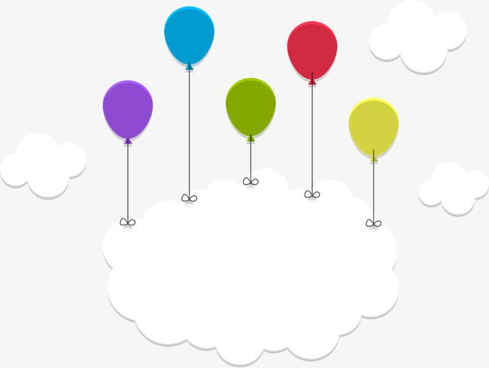
ภาคผนวก

ประมวลภาพกิจกรรมต่างๆ

....................................................................................................................................................

....................................................................................................................................................

